**TAKE HOME TASK**

EBAD ALI

24k-0882

#include <iostream>

using namespace std;

const int cities = 4;

const int days = 7;

void enterAQI(int aqi[cities][days]);

void calculateAvgAQI(int aqi[cities][days]);

void findHighPollutionDays(int aqi[cities][days]);

void displayAQIChart(int aqi[cities][days]);

void showReport(int aqi[cities][days]);

void enterAQI(int aqi[cities][days]) {

cout << "Enter AQI for " << cities << " cities over " << days << " days:\n";

for (int i = 0; i < cities; i++) {

cout << "City " << (i + 1) << ":\n";

for (int j = 0; j < days; j++) {

cout << "Day " << (j + 1) << ": ";

cin >> aqi[i][j];

}

}

}

void calculateAvgAQI(int aqi[cities][days]) {

float avgAQI[cities] = {0};

int worstCity = 0;

for (int i = 0; i < cities; i++) {

int total = 0;

for (int j = 0; j < days; j++) {

total += aqi[i][j];

}

avgAQI[i] = total / days;

cout << "Average AQI for City " << (i + 1) << ": " << avgAQI[i] << endl;

if (avgAQI[i] > avgAQI[worstCity]) {

worstCity = i;

}

}

cout << "City with the worst air quality: City " << (worstCity + 1) << " with average AQI of " << avgAQI[worstCity] << endl;

}

void findHighPollutionDays(int aqi[cities][days]) {

cout << "High Pollution Days (AQI > 150):\n";

for (int i = 0; i < cities; i++) {

cout << "City " << (i + 1) << ": ";

bool hasHighPollution = false;

for (int j = 0; j < days; j++) {

if (aqi[i][j] > 150) {

cout << "Day " << (j + 1) << " ";

hasHighPollution = true;

}

}

if (!hasHighPollution) {

cout << "None";

}

cout << endl;

}

}

void showReport(int aqi[cities][days]) {

cout << "\n*** AQI Report ***\n";

for (int i = 0; i < cities; i++) {

float weeklyAvg = 0;

int maxAQI = aqi[i][0];

int minAQI = aqi[i][0];

for (int j = 0; j < days; j++) {

weeklyAvg += aqi[i][j];

if (aqi[i][j] > maxAQI) {

maxAQI = aqi[i][j];

}

if (aqi[i][j] < minAQI) {

minAQI = aqi[i][j];

}

}

weeklyAvg /= days;

cout << "City " << (i + 1) << ":\n";

cout << " Weekly Average AQI: " << weeklyAvg << endl;

cout << " Highest AQI: " << maxAQI << endl;

cout << " Lowest AQI: " << minAQI << endl;

}

cout << "\n*** High Pollution Days Summary ***\n";

for (int i = 0; i < cities; i++) {

cout << "City " << (i + 1) << " High Pollution Days: ";

bool hasHighPollution = false;

for (int j = 0; j < days; j++) {

if (aqi[i][j] > 150) {

cout << "Day " << (j + 1) << " ";

hasHighPollution = true;

}

}

if (!hasHighPollution) {

cout << "None";

}

cout << endl;

}

}

void displayAQIChart(int aqi[cities][days]) {

cout << "AQI Chart (Each '*' represents AQI of 50):\n";

for (int i = 0; i < cities; i++) {

cout << "City " << (i + 1) << ": ";

for (int j = 0; j < days; j++) {

int stars = aqi[i][j] / 50;

for (int k = 0; k < stars; k++) {

cout << "*";

}

cout << " ";

}

cout << endl;

}

}

int main() {

int aqi[cities][days];

enterAQI(aqi);

calculateAvgAQI(aqi);

findHighPollutionDays(aqi);

displayAQIChart(aqi);

showReport(aqi);

return 0;

}

OUTPUTS:

TASK 1:  
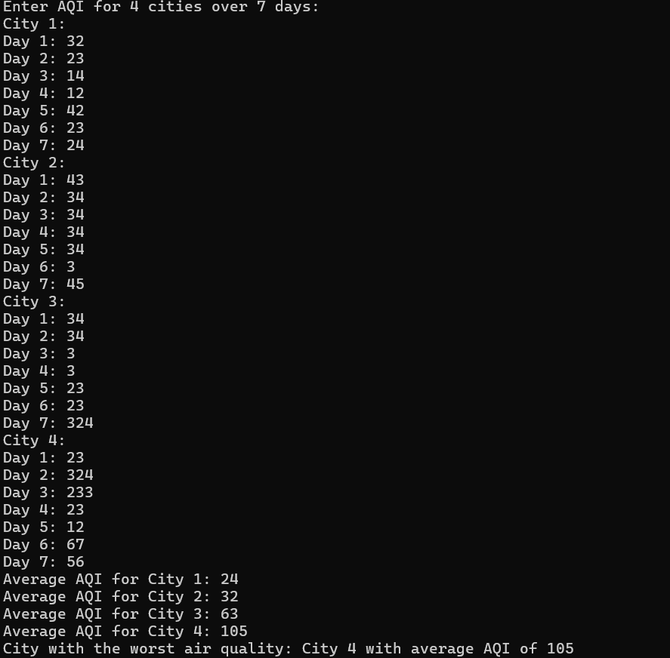

TASK 2:  
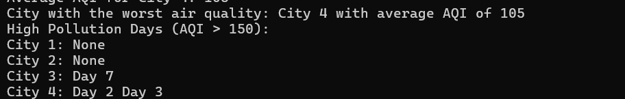

TASK 3:

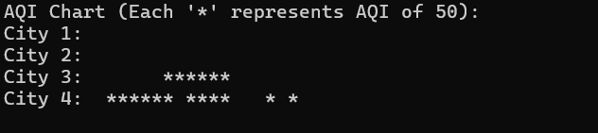

TASK 4 AND 5:

